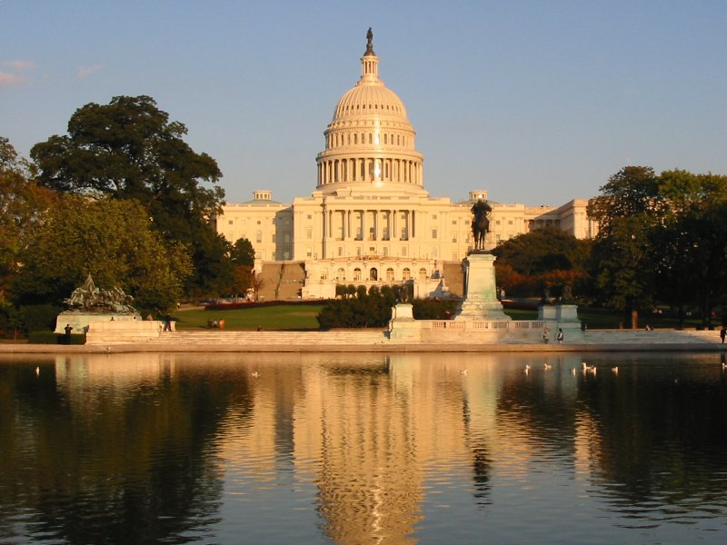
Capitol Building
Senate Bill
Senator __________________ Circle Party: Democrat/ Republican
State ____________________

On this _______ day of September 20____, I hereby propose that ____________________________________________________________________________________________________________________________________________________________________________________________________________________________________________________________________________________________________________________________________________________________________________________________________________
Reason One ____________________________________________________________________________________________________________________________________________________________________________________________________________________________________________________________________________________________________________________________________________________________________________________________________________

Reason Two ____________________________________________________________________________________________________________________________________________________________________________________________________________________________________________________________________________________________________________________________________________________________________________________________________________

Capitol Building
House of Representatives Bill
Representative _________________ Circle Party: Democrat/ Republican
State ____________________

On this _______ day of September 20____, I hereby propose that ____________________________________________________________________________________________________________________________________________________________________________________________________________________________________________________________________________________________________________________________________________________________________________________________________________
Reason One ____________________________________________________________________________________________________________________________________________________________________________________________________________________________________________________________________________________________________________________________________________________________________________________________________________

Reason Two ____________________________________________________________________________________________________________________________________________________________________________________________________________________________________________________________________________________________________________________________________________________________________________________________________________

